**Problem statement**

**Problem Statement:** Most pharmacies faced problems such as insufficient service promotions, lack of coherence of pharmacy services in hospitals, poor drug information systems, and the inconsistency of the pharmacy information management due to its manual processes. Now, these are the problems that must be solved with this Pharmacy Management System Project Proposal.

**Solution**: Pharmacy Management System Project is a great system for storing data, maintaining, and organizing the use and process of medications in the pharmacy. This computer software is programmed to perform the various tasks required in the operation of a pharmacy. The system will improve the efficiency of the pharmacy and enable the storing of digital records. Managing a system for pharmacy is the process of creating and implementing evidence-based pharmaceutical usage strategies to improve member and population health while maximizing healthcare resources.

The purpose of this proposal is to answer the needs and problems that are seen in pharmacy management. To formulate the project proposal of this pharmacy management, you should address its problem first. By determining its problem you can have ideas on what should be the modules or features of the Pharmacy Management System Project.

**Scope:** One of the most important responsibilities of pharmacy management is to supervise and manage the pharmacy employees to ensure healthy working relationships and outcomes. Each of these functions is critical to the pharmacy’s operation and should be improved.

**MODULES**

* **Pharmacy Information Management:** is a multi-functional system that helps pharmacists to keep track of medicine supplies and organize them. The modules aids in the reduction of medication errors, the improvement of patient safety, the reporting of drug usage, and the tracking of expenses.
* **Medicine Management:** To manage medicines modules will assess the need for and use of medication, the patient’s response to medication, and the patient’s level of understanding of the drug and how to take it with the patient.
* **Categorize Medicine Information:** Categorizing the drugs available in the pharmacy will be much easier for the admin through the help of this module. This will do the monitoring and checking of the medicine information to identify its category.
* **Monitor Medicine Orders:** is used to keep track of dates and events throughout the process chain, from placing an order with an external vendor to presenting goods in a store or receiving goods in a distribution center.
* **Manage Sales and Stocks:** This module will help the Pharmacist with the sales and stocks management that includes ordering, storing, tracking, and monitoring stock levels as well as monitoring their revenue.
* **Drug Inventory Management:** The drug inventory management module strives to reduce procurement and carrying expenses while maintaining a sufficient stock of products to meet the needs of customers and prescribers. This will also monitor the performance of the pharmacy and to know what are the most needed medicines.
* **Generate Processes Reports:** In all organization or business, reports are very essential. To help the admin in these matters, this module generates the transaction reports to keep track of the pharmacy activities.

Summary:

The role of pharmacy management is to supervise and manage the pharmacy employees to preserve excellent working relationships and outcomes. To improve the services offered in every Pharmacy, the formulated proposal, abstract and modules of Pharmacy Management System Project management should be present in the PDF document.

And that ends our discussion about Pharmacy Management System Project Proposal, Modules, and Documentation. You may check the complete illustration of Diagrams, Source Codes, and Documentation by clicking the titles of each explanation.

**USE CASE**

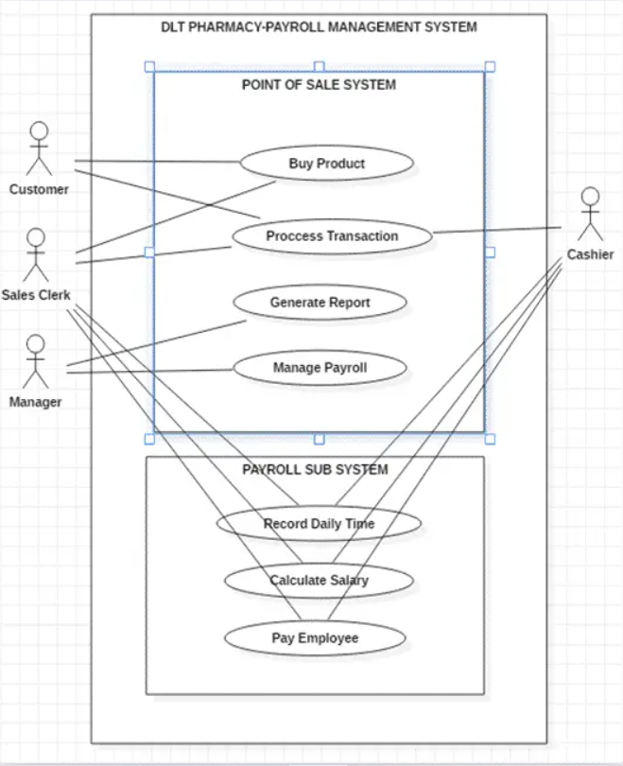

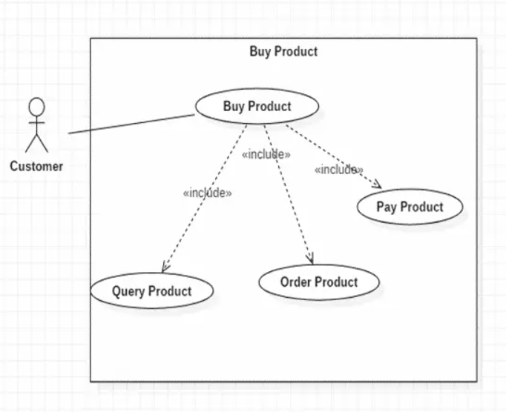

**ER**

